Bahria University,

Karachi Campus



LAB EXPERIMENT NO.

**1**

LIST OF TASKS

|  |  |
| --- | --- |
| TASK NO | OBJECTIVE |
| **1** | **Write a Python program to calculate the roots of a quadratic equation of the form ax2 + bx + c = 0, where a, b, and c are coefficients provided by the user.** |
| **2** | **Write a Python program that calculates the factorial of a non-negative integer n provided by the user.** |
| **3** | **Write a python program to find the maximum and minimum number in the following array {12,56,34,2,56,98,6,54,6,54}** |
| **4** | **Write a Python program that checks whether a given positive integer n provided by the user is a prime number or not.** |
| 5 | Write a python program that takes two matrix (2 by 2) from user, and perform addition, subtraction, multiplication and division on them. |

Submitted On:

**Date: ___________**

**Task No. 01:**

**Write a Python program to calculate the roots of a quadratic equation of the form ax2 + bx + c = 0, where a, b, and c are coefficients provided by the user.**

**Solution:**

import cmath

a=int(input('Enter a: '))

b=int(input('Enter b: '))

c=int(input('Enter c: '))

D=(b*b)-(4*a*c)

x1=(-b+cmath.sqrt(D))/(2*a)

x2=(-b-cmath.sqrt(D))/(2*a)

print('x1: ',x1)

print('x2: ',x2)

**Output:**

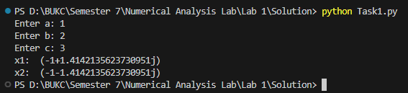

**Task No. 02:**

**Write a Python program that calculates the factorial of a non-negative integer n provided by the user.**

**Solution:**

def factorial(n):

if(n<=1):

return 1

else:

return n*factorial(n-1)

while(True):

n=int(input('Enter number: '))

if(n<0):

print('Please Enter +ve Number')

else:

break

print(factorial(n))

**Output:**

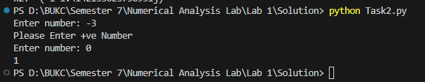

**Task No. 03:**

**Write a python program to find the maximum and minimum number in the following array {12,56,34,2,56,98,6,54,6,54}**

**Solution:**

n_list=[12,56,34,2,56,98,6,54,6,54]

n_list.sort()

print('Maximum: ',n_list[0])

print('Minimum: ',n_list[len(n_list)-1])

**Output:**

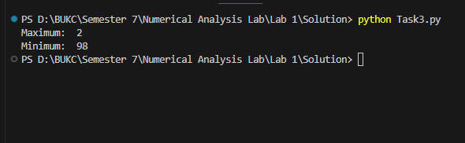

**Task No. 04:**

**Write a Python program that checks whether a given positive integer n provided by the user is a prime number or not.**

**Solution:**

while(True):

n=int(input('Enter any positive number: '))

if(n>=1):

if((n==2)|(n==3)):

print('Number is prime')

elif((n==1)):

print('Number is not prime')

else:

if((n%2==0)|(n%3==0)):

print('Number is not prime')

else:

print('Number is prime')

break

else:

print('Number is not +ve')

continue

**Output:**

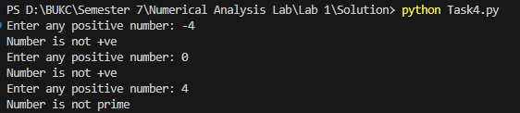



**Task No. 05:**

**Write a python program that takes two matrix (2 by 2) from user, and perform addition, subtraction, multiplication and division on them.**

**Solution:**

def getMatrix(row,col):

mat=[]

for i in range(row):

r=[]

for j in range(col):

n=int(input(f'Input element at position ({i+1},{j+1}): '))

r.append(n)

mat.append(r)

return mat

def printMatrix(mat):

for row in mat:

print(' '.join(map(str,row)))

def Addition(matA,matB,r1,c1):

res=[]

for i in range(r1):

row=[]

for j in range(c1):

row.append(matA[i][j]+matB[i][j])

res.append(row)

return res

def Subtraction(matA,matB,r1,c1):

res=[]

for i in range(r1):

row=[]

for j in range(c1):

row.append(matA[i][j]-matB[i][j])

res.append(row)

return res

def Multiplication(matA,matB,r1,r2,c1,c2):

res=[]

for i in range(r1):

t_res=[]

for j in range(c2):

temp=0

for k in range(c1):

temp+=matA[i][k]*matB[k][j]

t_res.append(temp)

res.append(t_res)

return res

r1=2

c1=2

r2=2

c2=2

matA=getMatrix(r1,c1)

print('Matrix A: ')

printMatrix(matA)

matB=getMatrix(r2,c2)

print('Matrix B: ')

printMatrix(matB)

print('Addition: ')

printMatrix(Addition(matA,matB,r1,c1))

print('Subtraction: ')

printMatrix(Subtraction(matA,matB,r1,c1))

print('Multiplication: ')

printMatrix(Multiplication(matA,matB,r1,r2,c1,c2))

**Output:**

